GOLDEN YEARS MARCH PROGRAMME
SPCA

FREE MEMBERSHIP AND ACTIVITIES FOR PEOPLE
AGED 60+ IN CAMDEN

WEEKLY ON ZOOM

MONDAYS 2pm-3pm GOLDEN YEARS SINGERS
No experience needed, just a love of singing

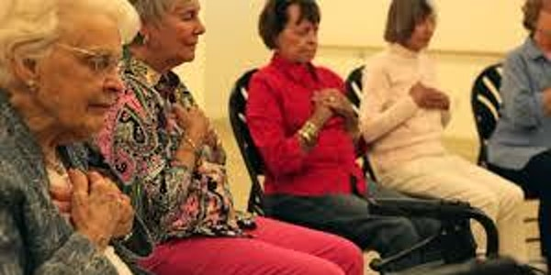
TUESDAYS 1pm-2pm MINDFULNESS MEDITATION
Gentle session to relax, reduce stress and anxiety and
improve sleep
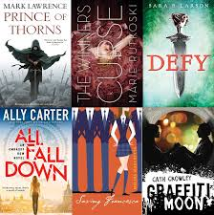

WEDNESDAYS 1pm-2pm BOOK GROUP
Read some great books & talk about them
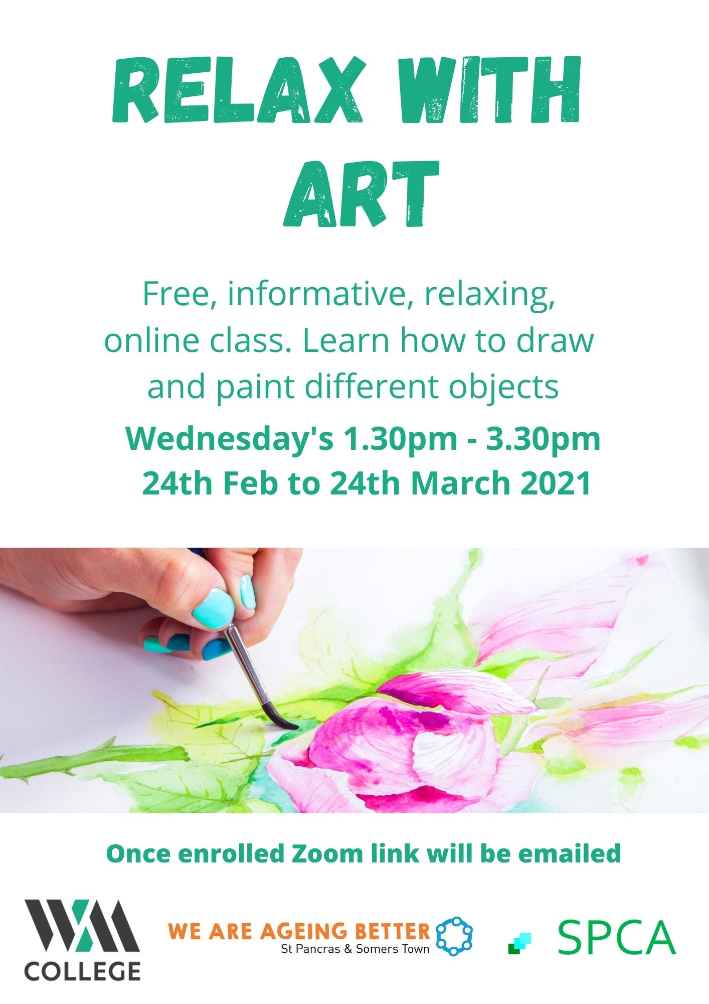

WEDNESDAYS 1.30-3.30pm RELAX WITH ART
Free creative drawing course run by Working Men’s College, enrolment is required

THURSDAYS 11am-11.30am WELLBEING AT HOME
Things we can do at home to improve our wellbeing

FRIDAYS 11am-12pm CHAIR EXERCISE
Gentle chair exercise session to improve health &
fitness
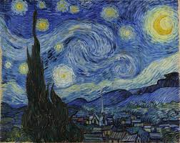

FRIDAYS 12pm-1pm ART HISTORY
Learn about the paintings you like and the artists
who created them

SPECIAL EVENTS
Tuesday 16 Mar 11am-12.30pm PLANTS & WELLBEING CREATIVE DRAWING
Wednesday 17th and 24th March 11am-12pm RELAX WITH YOGA

For more information call Jane on 07754 328 295 or goldenyears@spca.org.uk
Saint Pancras Community Association

