We would like you to join us on the 27th of June to help us think about how we achieve our vision for mental health in Camden.
It will be an opportunity to hear about our vision for North Central London and our local plans to improve mental health across Camden. We will also talk about some of the current and future challenges.

This event is for anyone who has an interest in mental health who lives in Camden; whether you are currently, or have used, mental health services, or are a carer for someone with a mental health problem.

Places are limited and registration before the event necessary.

10am-4pm (lunch provided) at
The London Irish Centre Charity
50-52 Camden Square
London NW1 9XB

To reserve a place and for more information please visit

www.mentalhealthcamden.co.uk

or call 0207974 3352/2868
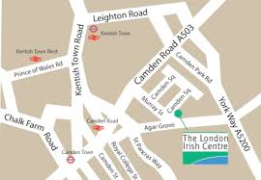

The London Irish Centre Charity
50-52 Camden Square
London NW1 9XB

Nearest Tube Camden Town, 8-10 minute walk
Nearest Overground Camden Road, 5 minute walk
Nearest Train station Kings Cross, 15 minute walk or 4 minutes in a taxi
Bus Routes 29, 253, 274.

